**Student Activity Guide: If Else Statements** Name ____________________

Unit 3 Lesson 10

**Directions**

We may need to redo the graphic – the original was done in Alice – this practice may seem ridiculous, but the kids love it

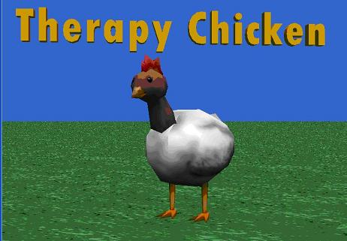

You have decided to start an on line therapist website. Your market research tells you that the animal people feel most comfortable talking to is a chicken. You are creating a prototype to show investors so you can raise money to launch your website. Using JavaScript create a website with your therapist chicken.

Ask the user's name and store it in a variable - people feel like they are being listened to if the chicken says their name.

Ask how old they are. If they are 16 or older say "So, you can drive". If not, give another message.

Ask at least three more questions about the user. Some ideas

* What grade are you in?
* How many classes are you taking?

The therapist chicken should respond based on if-else statements.